Ideation Phase
Define the Problem Statements

Date | 24 September 2022
Team ID | PNT2022TMID13523
Project Name | Analytics For Hospitals Healthcare Data
Maximum Marks | 2 Marks

Customer Problem Statement Template:
Create a problem statement to understand your customer's point of view. The Customer Problem Statement template helps you focus on what matters to create experiences people will love.
A well-articulated customer problem statement allows you and your team to find the ideal solution for the challenges your customers face. Throughout the process, you’ll also be able to empathize with your customers, which helps you better understand how they perceive your product or service.

Reference: https://miro.com/app/board/uXjVPPDGsug=/
Example:
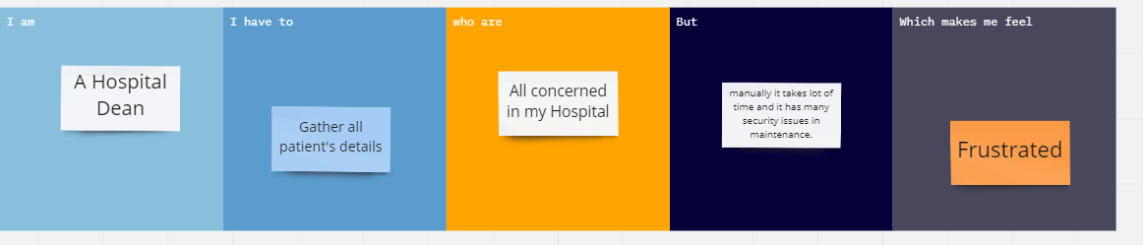

Problem Statement (PS) | I am | I have to | Who are | Because | Which makes me feel
PS-1 | A Hospital Dean | Gather all patient's  details | All concerned in my Hospital | manually it takes lot of time and it has many security issues in maintenance | Frustrated

